**Data Modulation**

Data modulation is a process that converts analog signals into digital signals and digital signals into analog signals. Computers store and process data in digital format. Data modulation allows computers to store and process analog signals.

Let’s take a simple example. When you record and play an audio clip, the following happens.

You use a microphone to record the audio clip. The microphone sends your voice to the computer. Since the human voice consists of analog signals, the computer converts the received voice into digital signals before processing and storing them onto the hard disk.

When the recorded clip is played, the computer reads digital signals from the hard disk and converts them into analog signals before sending them to the speaker.

**The following image shows this process.**

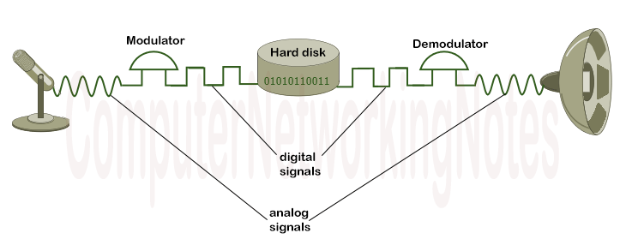

Modulators and demodulators are devices or chips or components that convert analog signals into digital signals and digital signals into analog signals, respectively.

Data modulation is not only used within the computer, but it is also used outside the computer. It allows computers to send digital signals on a media that can only carry analog signals. It converts signals in such a way that they become suitable for transport on a communication path that is not designed to carry such signals.

For example, telephone lines are designed to carry analog signals. Through data modulation, the same telephone lines can also be used to provide the Internet facility. To provide the Internet facility through telephone lines, a device known as the **modem** is used. A modem can act as both a modulator and a demodulator.

A modem connects a computer to the ISP network via a telephone line. It modulates digital signals into analog signals at the transmitting end, then demodulates analog signals into digital signals at the receiving end.

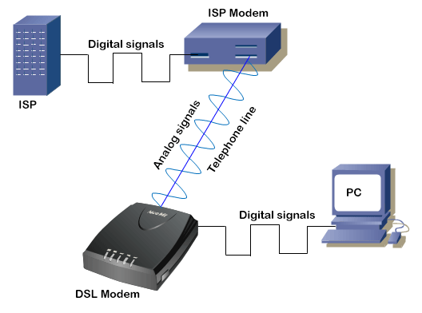

### **How does the data modulation work?**

To convert digital signals into analog signals, a simple analog wave, known as the **carrier wave**, is combined into digital signals. A carrier wave does not contain any information or data. In simple words, it’s only a messenger that transfers information between two nodes.

An analog wave has four properties; amplitude, frequency, wavelength, and phase. From these, amplitude and frequency are used to blend digital signals. To load digital signals on the analog wave, the modulator modifies either **amplitude** or **frequency** in a pre-defined way.

**[How analog and digital signals work](https://www.computernetworkingnotes.com/networking-tutorials/how-analog-and-digital-signals-work.html" \t "https://www.computernetworkingnotes.com/networking-tutorials/_blank)**

After modification, the modulator loads the blended wave on the media. When the blended wave reaches its destination, the demodulator separates the data from the blended wave by using the same pre-defined way. After separation, the data is sent on its destination in the digital format and the carrier wave is discarded.

The following image shows an example of this process.

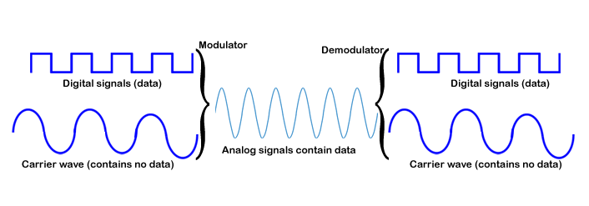

### **Types of modulation**

* [Amplitude modulation](https://whatis.techtarget.com/definition/amplitude-modulation-AM)(AM), in which the height -- i.e., the strength or intensity -- of the signal carrier is varied to represent the data being added to the signal.
* [Frequency modulation](https://searchnetworking.techtarget.com/definition/frequency-modulation)(FM), in which the frequency of the carrier waveform is varied to reflect the frequency of the data.
* [Phase modulation](https://whatis.techtarget.com/definition/phase-modulation-PM)(PM), in which the phase of the carrier waveform is varied to reflect changes in the frequency of the data. In PM, the frequency is unchanged while the phase is changed relative to the base carrier frequency. It is similar to FM.
* Polarization modulation, in which the angle of rotation of an optical carrier signal is varied to reflect transmitted data.
* [Pulse-code modulation](https://searchnetworking.techtarget.com/definition/pulse-code-modulation-PCM), in which an analog signal is sampled to derive a data stream that is used to modulate a digital carrier signal.
* Quadrature amplitude modulation ([QAM](https://searchnetworking.techtarget.com/definition/QAM)), which uses two AM carriers to encode two or more bits in a single transmission.

